Bounds Green Hub
Patient Guidance for visiting the HOT HUB

The HOT HUB has been set up to review patients in Haringey who either have Covid related illness or may have Covid with another urgent medical problem. Either your practice or 111 have referred into the service.
IMPORTANT: Please be aware that staff will be wearing Personal protection equipment and will be masked. If you are attending with a child please explain this to the child in preparation.
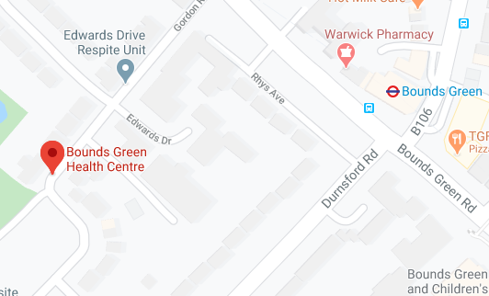
Address:
Bounds Green Health Centre
Gordon Road
London
N11 2PA

PLEASE NOTE THIS IS NOT THE GP
PRACTICE – FOLLOW SIGNS TO THE HOT
HUB

What to do when you arrive:
- Please call number (Tel 07776 495884) to say you have arrived. Then wait outside or in the car (do not come to the entrance to the hub)
- A member of the team will come to the car and give you a surgical mask.
- Put on the surgical mask to cover your mouth and nose (protecting you and staff in the hub)
- You will be invited to clean your hands with hand gel
- You will be directed into the building by the team member and then to the room
- Please try not to touch anything as you enter.
- When you enter the room, please sit on the allocated chair and wait for the GP

What will happen Next?
- You will be asked a series of questions by the clinician
- You may have a limited examination including checking your oxygen levels with a probe that fits on your finger (please note it is unlikely you will have your chest examined as this is advised against with Covid infections)
- The clinician may ask you to wait while they write notes or they may even call you from another room: this is to reduce infection
- The clinician will then advise you of the plan to care for you
- You will be directed back out to your car
PLEASE NOTE YOU MAY FIND THAT DURING THE TELEPHONE OR VIDEO CALL YOU ARE DEEMED SAFE TO GO HOME & DO NOT NEED TO ENTER THE HUB

